

TradersNews Adds New Hourly Indexes

Unprecedented Hedging Strategies

TradersNews Energy™ supplies the North American wholesale power markets with innovative hedging tools through its exclusive hourly price indexes.

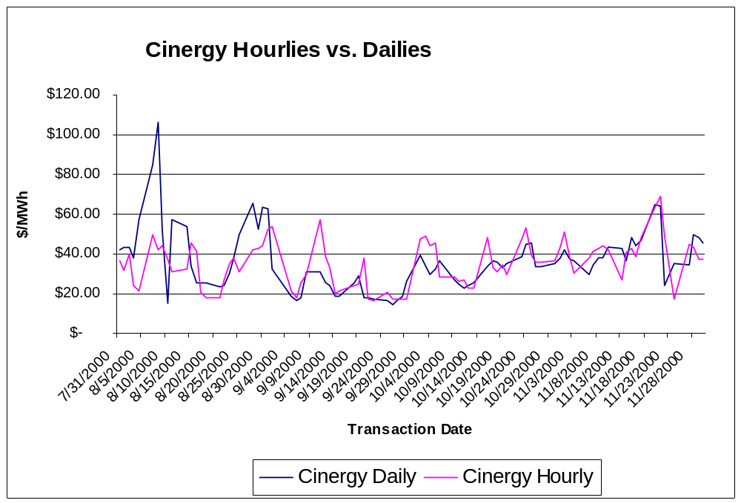

Hourly coverage:
Plus: Daily Indexes & the most comprehensive Forwards available.
Cinergy
AEP/No. ECAR
Entergy/SPP
TVA/SERC NEW!
ComEd/MAIN NEW!
ERCOT NEW!

- The only indexes tracking the hourly markets.

- Next-day assessments offer a clearer picture of the markets' volatility – and strategies for profiting from it.

The market agrees: TradersNews Indexes are the benchmark for financial hourly trading.

“This is extremely valuable. This is more information than any marketer has ever seen in their life.”

“This is an ideal tool. I hope my counterparties don’t get this.”

“You guys have a great product. The market needs an agreed-upon hourly market price.”

New Tools for:

- Wholesale Power Traders – Swaps; index trades; tools for improving trading strategies. EnronOnline offers a swap based on the Cinergy hourly index.
- Risk Managers – Tracking of physical power movement allows greater precision in Value at Risk modeling.
- Back Office/Accounting – Independent price benchmark for Mark to Market and internal transfer accounting.
- Asset Managers/Independent Power Producers – Historical pricing, volumes, weighted averages by hour for improved inter-fuel analysis, load forecasting, ramping decisions.
- Retail Marketers/Large Industrial & Commercial Energy Consumers – Tool for negotiating power contracts; independent price benchmark for dispute resolution, replacement power costs.

Cinergy Hub Hourly On-Peak Trades for 01/09/01
Hour Ending: | WEIGHTED AVG. PRICE | LOW | HIGH | TOT VOL  (MW) | 4-HOUR AVG.
7 | $ 77.09 | $ 75.00 | $ 87.00 | 775
8 | $ 80.60 | $ 80.00 | $ 87.00 | 860
9 | $ 75.56 | $ 75.00 | $ 80.00 | 754 | 7 – 10:
10 | $ 69.71 | $ 63.00 | $ 77.50 | 1,093 | $ 75.74
11 | $ 54.25 | $ 50.00 | $ 70.00 | 1,325
12 | $ 42.99 | $ 40.00 | $ 55.00 | 1,362
13 | $ 40.59 | $ 35.00 | $ 48.00 | 1,360 | 11 – 14:
14 | $ 48.60 | $ 40.00 | $ 70.00 | 1,235 | $ 46.61
15 | $ 37.42 | $ 36.00 | $ 43.50 | 690
16 | $ 37.88 | $ 30.00 | $ 43.50 | 775
17 | $ 65.37 | $ 53.00 | $ 85.00 | 1,146 | 15 – 18:
18 | $ 76.23 | $ 65.00 | $ 85.00 | 775 | $ 54.23
19 | $ 75.56 | $ 65.00 | $ 85.00 | 1,160
20 | $ 76.02 | $ 75.00 | $ 85.00 | 1,080
21 | $ 74.29 | $ 58.00 | $ 80.00 | 1,240 | 19 – 22:
22 | $ 68.78 | $ 60.00 | $ 70.00 | 1,225 | $ 73.66
TradersNews Index | $ 62.56 |  |  | 16,855

For More Information: Call TradersNews at 1-888-TNE-1006, or visit www.tradersnewsenergy.com. In addition to the exclusive TradersNews Hourly Indexes, you’ll also receive TradersNews’ power and natural gas industry and market news.

TradersNews, a service of Internet Publishing Group™, is not affiliated with any energy company. Founded by five former Dow Jones executives in 1999, Internet Publishing Group (www.ipgdirect.com) is an information services company serving clients in energy, commercial real estate and construction.

Knowledge is Power…

How Powerful Do You Want to Be?

Knowledge is Power…

How Powerful Do You Want to Be?

